**Screen Mockups**

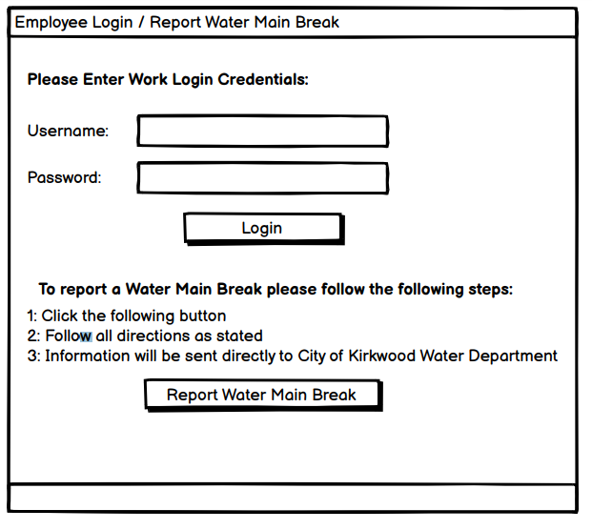

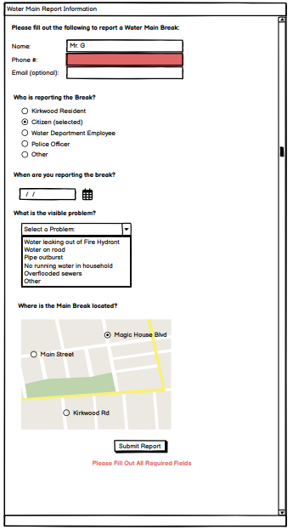

**UML**

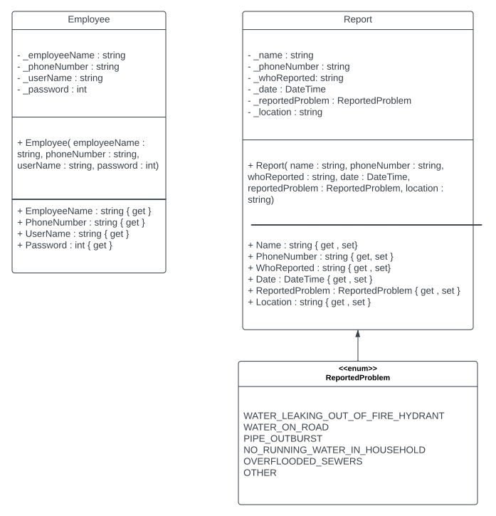

**FEATURES**

1. **LOGIN SYSTEM:** This is the first thing a user sees upon running the application. They can enter either a provided work username and password if they are employees of the City of Kirkwood Water Department. Upon successful login, it will redirect them to the employee’s main screen where they can see the information for the day about.
2. **CURRENTLY WORKING EMPLOYEES:** Employees once logged in can see a list of all the current employees working depending on the current date. Depending on the day the application is ran on, the employees working for that day will change.
3. **REPORTING A WATERMAIN BREAK:** If the user clicks the Report Water Main Break Button it will direct them to the report form in which they can fill out information. They must enter all fields except for email. If any of the fields are left blank an error will appear showing that all fields must be completed. This is so no “fake” or “false” breaks can be reported. Unfilled fields will appear red. User must enter a name and phone number or the optional email for additional contact if the Water Department sees fit.